* Search on github for android animations.
* Androidviewanimation
* Copy

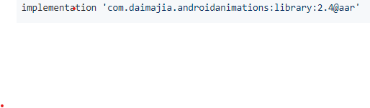

* Go to



* Paste the line here

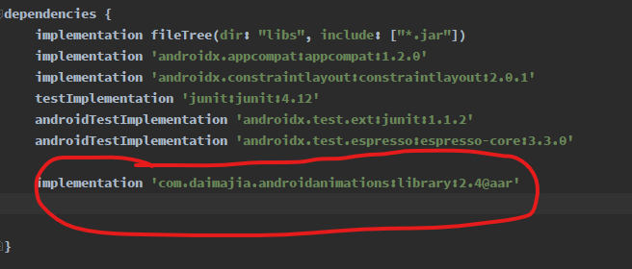

* Then sync to get the package for our application

